IMRP Conference and Travel Policy
Academic Conference Leave: Residents are granted 2 days per year to attend an academic conference at which they are presenting. Days in addition to this will be applied to wellness days, holiday make up days, reading days, or vacation.
Process: As soon as you are accepted to present, complete the Resident Travel Funding Request Jotform. Link here https://form.jotform.com/250613910444147 and on Wildcat Med. Residents on inpatient rotations will be responsible for arranging their own coverage if needed and communicating this to the schedule chief.
Reimbursement: One author will be reimbursed per poster presentation. Our department will reimburse up to $1250 per academic year. University policies govern acceptable dates which include the dates of conference and travel time (varies by location). We cannot reimburse costs before or after the portions of the conference that you are registered to attend. (Separate policy if you must combine business and personal travel). You are expected to attend the conference for majority of the time to justify this as a business purpose.
Travel planning: Based on the date/time of your presentation and your rotation, you may be able to attend more of the conference vs. some rotations (wards/ICU) with limited time for travel. This is true in all of academic medicine—even for faculty.
Hotel nightly rates shall not exceed the published rates on the conference website; you can often find lower cost hotels not immediately adjacent to the conference site. See below for how to split hotel charges.
To simplify reimbursement, it is strongly encouraged to book directly with hotels/airlines (rather than 3rd party vendors, as it is more difficult itemized receipt). Your name and proof of payment must be on all receipts.
Poster Printing: We need ~1 week of turnaround time. Please send final document and the designated poster size for your meeting to Danier Rose. Without sufficient lead time, you may be referred to printing providers out in town at your own expense.
Documentation: Here is what is needed to get reimbursed—notice all contain proof of payment (circled) and are itemized (provides breakdown of taxes and/or fees).
1) Conference itinerary/schedule: REQUIRED FOR ALL. Easiest way is to send staff PDF or web link to the “At a Glance” schedule from conference.

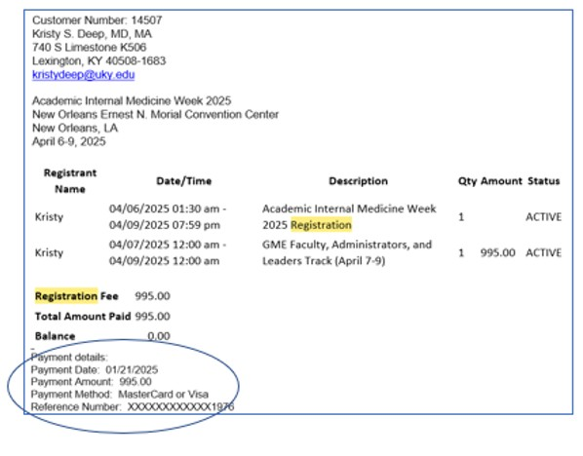
2) Conference registration: A confirmation email (similar to this) will be sent to you when you register. Please forward that email.

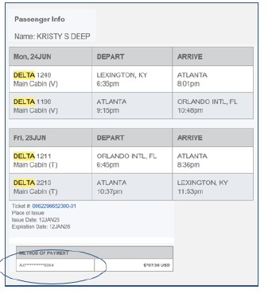
3) Flight receipt: Forward the email from airline you received immediately after purchasing flight. Usually has subject of “Your trip confirmation” or “Your flight receipt”. Shows where, when, and payment source.

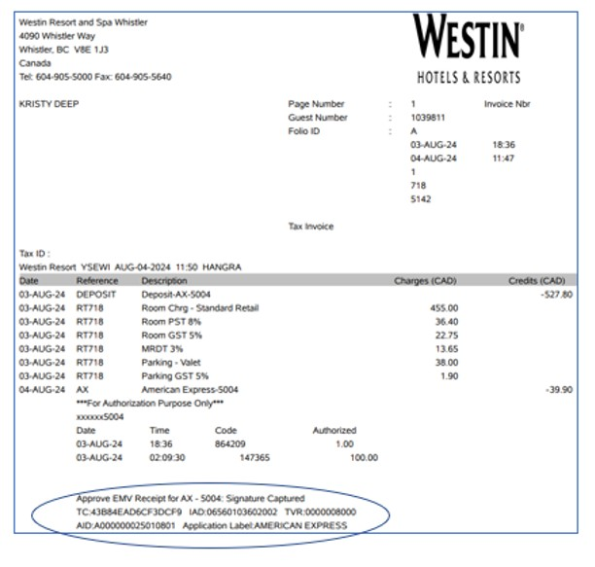
4) Hotel folio receipt: Request it be emailed to you at checkout. Email will almost always include attached PDF of folio—forward to staff. If sharing room, ask hotel for split charge at checkout with folio for each person showing their payment amount.

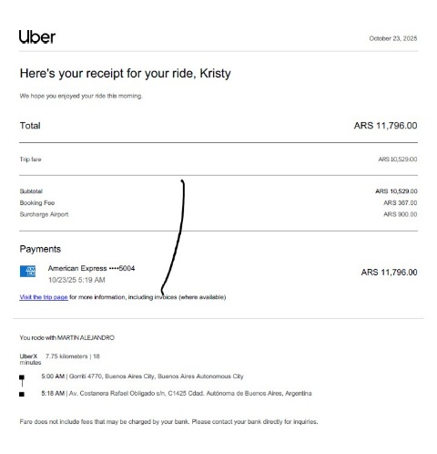
5) Rideshare charge: Email or use app to send receipt that shows location and fees. Forward to Danier Rose.

Questions? Contact Danier Rose

